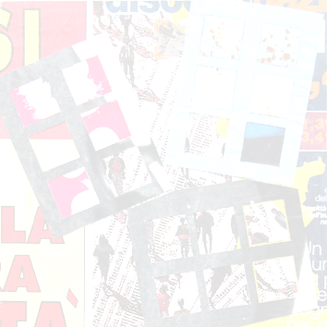  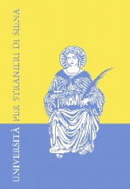 | UNIVERSITÀ PER STRANIERI DI SIENA

DADR  Dipartimento di Ateneo per la Didattica e la Ricerca | Centro CLASS  Centro per le Lingue Straniere | Centro DITALS  Certificazione di competenza  in didattica dell’italiano a stranieri

Draft Programme

Subtitling and Intercultural Communication
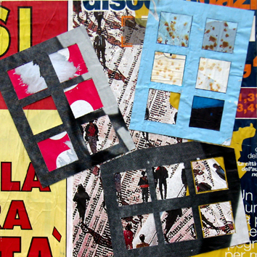
European Languages and beyond

Bruno Sullo, Beyond the Poster n.10 - 2007, cm 70x70

Siena, 27 February 2014, Aula Magna

9:00 – 9:15 Greetings from the Chancellor, Professor Monica Barni and from
the Head of DADR, Professor Pietro Cataldi
Chair: Claudia Buffagni
9:15 – 10:30 Subtitling and Intercultural Communication – Keynote Speakers
9:15 – 9:45 Yves Gambier (University of Turku), Thirty Years of Research in Subtitles and Language
Learning. The knowns and unknowns
9:45 – 10:15 David Katan (Università del Salento), Intercultural Communication, Mindful Translation and Squeezing ‘Culture’ onto the Screen
10:15 – 10:30 Discussion

Chair: Massimo Palermo
10:30 – 11:30 Subtitling for different audiences in Europe and beyond - I
10:30 – 10:45 Silvia Bruti, Veronica Bonsignori (Università di Pisa), Across lingua-cultures: Introductions and wishes in subtitled TV series
10:45 – 11:00 Lynn Penrod, Anne Malena (University of Alberta), We’e all been to Ch’tiland
11:00 – 11:15 Stefania Carpiceci (Università per Stranieri di Siena),“La terra trema” di Luchino Visconti: un caso paradigmatico?
11:15 – 11:30 Discussion

11:30 – 11:45 Coffee break

Chair: Michela Baldo
11:45 – 13:00 Subtitling for different audiences in Europe and beyond – II
11.45 – 12:00 Vincenzo Alfano (University of Hull), Semiotic cohesion in the English subtitling of gender stereotypes: The case of the Commedia all’italiana
12:00 – 12:15 Serenella Zanotti (Università Roma Tre), "Am I wired wrong or something?": The translation of vague language in subtitles
12:15 – 12:30 Jasmina Lazic (University of Belgrade), Language as a cultural marker: Audiovisual translation challenges and implications: Bubamara – enana /“dwarf” or mariquita/“ladybird”?
12:30 – 12:45 Jing Han (University of Western Sydney), Audience Design in Translation
12:45 – 13:00 Discussion

13:00 – 14:30 Lunch break

Chair: Beatrice Garzelli
14:30 – 15:45 Subtitling and Intercultural Communication – Keynote Speakers
14:30 – 15:00 Henrik Gottlieb (University of Copenhagen), Foreign voices, domestic lines: Language political implications of subtitling
15:00 – 15:30 Jorge Díaz-Cintas (University College London), Braving a new media world: the case of fansubbing
15:30 – 15:45 Discussion

Chair: Andrea Villarini
15:45 – 16:45 Subtitling for deaf and hard of hearing audiences
15:45 – 16:00 Susanne J. Jekat (Zurich University of Applied Sciences), Evaluation of live-subtitles
16:00 – 16:15 Julia Beer (Hochschule Magdeburg-Stendal), A study on the peculiarities of subtitling recorded sign language texts
16:15 – 16:30 Marta Miquel Iriarte (University of Turku), Do you see what I read? Comprehension of multimodal information in films with SDH
16:30 – 16:45 Discussion

16:45 – 17:00 Coffee break

Chair: Stefania D’Agata D’Ottavi
17:00 – 18:15 New technological frontiers of subtitling around the world
17:00 – 17:15 Noa Talaván, Pilar Rodríguez-Arancón (Universidad Nacional de Educación a Distancia), The use of interlingual subtitling to improve listening comprehension skills in advanced efl students
17:15 – 17:30 Lindsay Bywood (University College London), Yota Georgakopoulou (Deluxe Media, London), Machine translation and subtitling: an overview
17:30 – 17:45 Raffaella Tonin (Università di Bologna), Il fansubbing nell’aula di traduzione multimediale: facciamo un po’ di spazio (anche) per l'interculturalità?
17:45 – 18:00 Gian Luigi De Rosa (Università del Salento), L'adeguatezza sociolinguistica come obiettivo:
doppiare e sottotitolare dal portoghese europeo (PE) e brasiliano (PB) all'italiano
18:00 – 18:15 Discussion

Siena, 28 February 2014, Aula Magna

Chair: Pierangela Diadori
9:00 – 10:30 Subtitling and Foreign Language Learning in Europe and beyond – I
9:00 – 9:15 Giovanna di Pietro (Università di Bari), “Tolle, transfer”: a hands-on approach to AVT in multilingual EFL classrooms
9:15 – 9:30 Arianna Alessandro (Universidad de Murcia), I sottotitoli nella didattica della fraseologia
9:30 – 9:45 Elisa Bricco, Anna Giaufret, Nancy Murzilli, Micaela Rossi (Università di Genova), La sottotitolazione come pratica didattica: uno strumento efficace per gli studenti francesisti del corso di laurea magistrale in Traduzione e Interpretariato?
9:45 – 10:00 Tomás Serrano Coronado (Universidad Nacional Autónoma de México), L’incontro con l’altro
10:00 – 10:15 Discussion

10:15 – 10:30 Coffee break

Chair: Donatella Troncarelli
10:30 – 11:45 Subtitling and Foreign Language Learning in Europe and beyond – II
10:30 – 10:45 Sara Laviosa (Università di Bari), Developing translingual and transcultural competence through pedagogic subtitling
10:45 – 11:00 Muhammad Y Gamal (University of Canberra), Subtitled films in the advanced interpreting class
11:00 – 11:45 Raffaella Romagnoli (Università di Bologna), Gli elementi del folklore nei film russi di animazione: nuovi stimoli verso la competenza interculturale
11:15 – 11:30 Tania Baumann (Università di Sassari), La sottotitolazione interlinguistica. Aspetti linguistici e culturali nella traduzione multimediale tedesco-italiano
11:30 – 11:45 Discussion

Scientific and Organising Committee: Michela Baldo, Claudia Buffagni, Pierangela Diadori, Beatrice Garzelli, Stefania Semplici, Donatella Troncarelli, Andrea Villarini

Università per Stranieri di Siena
Piazza Carlo Rosselli 27/28- I-53100 Siena
Tel. +39.0577.240369; +39.0577.240315
Fax +39.0577.240380;+39.0577.240383
Email: congress_subtitling@unistrasi.it
salvini@unistrasi.it
www.unistrasi.it

